***Poodle stuffed dog***

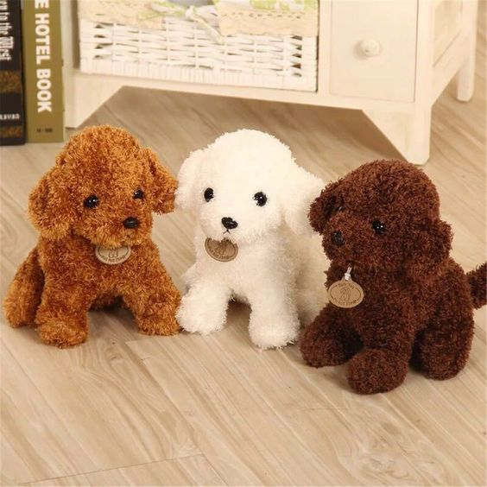

*Poodles are made of high quality cotton.  
Size 30 cm.  
Available in 3 colors: white, brown and yellow.  
This dog has a very cute and funny face.  
Suitable as gifts for girlfriends, gifts for children.  
"*